**2021-2022 African American Educational Equity Scholarship at the Community Foundation for Southern Arizona**

**The application deadline has been extended to March 24, 2021, no later than 5:00 PM MST.**

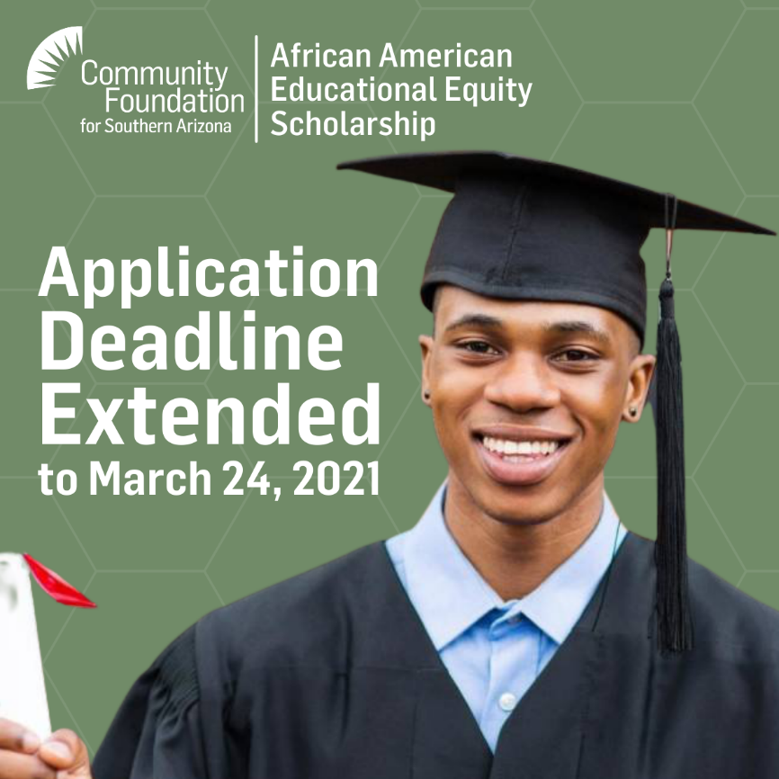

This scholarship awards $2,000 to high school seniors beginning their 2 or 4-year studies in the 2021-2022 academic year OR current college students who are enrolled full-time. Applications will also be accepted by part-time students pending future full-time status. **Students must have attended high school in Tucson, Arizona.**

African American Education Equity Scholarship applications must be submitted online through Common Grant Application. Detailed instructions are available on the Community Foundation for Southern Arizona's website here: [https://cfsaz.org/scholarships/aaee](https://nam04.safelinks.protection.outlook.com/?url=https%3A%2F%2Fcfsaz.org%2Fscholarships%2Faaee&data=04%7C01%7CVictoria.Bacal%40tusd1.org%7C783202fee9eb40926c6e08d8e5780f78%7Cbc7050e04bcc48099245ea8b65084865%7C0%7C0%7C637511651153389382%7CUnknown%7CTWFpbGZsb3d8eyJWIjoiMC4wLjAwMDAiLCJQIjoiV2luMzIiLCJBTiI6Ik1haWwiLCJXVCI6Mn0%3D%7C1000&sdata=sgM5BBwNYm3ja1YdFweRDXJp5E0Rs5Q6bLocpdrLrCo%3D&reserved=0)/

Questions? Contact **Jeaiza Quinones Ivory**, Program Manager, Scholarships, at [**jqivory@cfsaz.org**](mailto:jqivory@cfsaz.org)or by phone at **520-770-0800 x 7129.**